**ABSTRACT**

Fitness Fusion's one-page WordPress website offers a concise and engaging overview of a fictional fitness studio's services and values. The Home section welcomes visitors with a dynamic layout, featuring a brief studio overview, featured classes or promotions, and call-to-action buttons for easy class booking.

The About section provides insight into the studio's history, mission, and values. The Training section details how trainers plan to train them.

The Training Gallery showcases studio facilities and classes, while the Clients section highlights client testimonials and community engagement. The Pricing section outlines membership options, and the Contact section provides contact details and a form for inquiries.

Overall, Fitness Fusion's website is designed to attract and inform potential clients, showcasing the studio as a welcoming and professional fitness destination.

**1. PROBLEM DEFINITION**

**1.1 Aim**

The aim of Fitness Fusion's one-page website is to effectively promote the studio's services and values, providing visitors with a comprehensive overview of what the studio has to offer. The website aims to attract new clients by highlighting the studio's welcoming atmosphere, experienced trainers, and diverse range of classes. It also aims to engage with existing clients by showcasing community testimonials and providing easy access to class schedules and booking options. Overall, the aim is to position Fitness Fusion as a leading fitness destination in the community, known for its commitment to helping individuals lead healthier and happier lives through fitness.

**1.2 Problem Definition**

**1.2.1 Existing System**  
The existing system for Fitness Fusion is characterized by a lack of digital presence and engagement strategies, relying heavily on traditional marketing methods. While the studio may have a basic website or social media presence, these platforms are underutilized and do not effectively showcase the studio's offerings or engage with potential clients. The website, if it exists, may lack updated information on classes, schedules, and trainers, making it challenging for prospective clients to get a comprehensive view of the studio. Additionally, the studio's social media presence may be sporadic, with infrequent posts and limited interaction with followers. This lack of engagement and consistency in online communication hinders the studio's ability to attract and retain clients in a competitive fitness market. Moreover, without a clear online booking system or inquiry form, potential clients may find it difficult to take the next step in joining the studio. Overall, the existing system's shortcomings highlight the need for a more robust and dynamic online presence to effectively promote Fitness Fusion's services and engage with a broader audience.

**1.2.2 Proposed System**  
The proposed system for Fitness Fusion is a comprehensive and user-friendly one-page WordPress website that aims to address the shortcomings of the existing system and enhance the studio's online presence. The website will feature a modern and visually appealing design, optimized for both desktop and mobile devices, to ensure a seamless user experience. The home section will serve as the main landing page, welcoming visitors with a dynamic layout and providing an overview of the studio's services, trainers, and facilities. It will include prominent call-to-action buttons for easy class booking or inquiries, encouraging visitors to take the next step in engaging with the studio. Overall, the proposed system aims to attract new clients and provide a user-friendly platform for engaging with existing clients.

**1.3 Objectives:**

The objective of the proposed system for Fitness Fusion is to enhance the studio's online presence, attract new clients, and improve engagement with existing clients. The website will serve as a comprehensive platform to showcase the studio's services, trainers, and facilities, providing potential clients with a clear understanding of what the studio has to offer. By featuring a modern and responsive design, the website will cater to a wide range of users, including those accessing the site from mobile devices. The inclusion of a dynamic home section with call-to-action buttons will encourage visitors to explore the website further and take the next step in booking classes or making inquiries. Additionally, the website will aim to build trust and credibility with potential clients by including testimonials from satisfied clients and providing transparent pricing information. Overall, the objective is to create a user-friendly and engaging online platform that reflects the studio's commitment to fitness and encourages individuals to join Fitness Fusion in their journey to a healthier lifestyle.

**2. SYSTEM ANALYSIS**

**2.1 Software Requirement Specifications**  
Software Requirement Specification (SRS) for Fitness Fusion Website:

1. **Introduction:**
   * Fitness Fusion is a one-page WordPress website designed to promote a fictional fitness studio.
   * The website aims to enhance the studio's online presence, attract new clients, and engage with existing clients.
2. **Functional Requirements:**
   * The website shall have sections for Home, About, Training, Training Gallery, Clients, Pricing, Testimonials, and Contact.
   * The Home section shall include a welcoming message, featured classes or promotions, and call-to-action buttons.
   * The About section shall provide information about the studio's history, mission, values, and bios of the trainers.
   * The Training section shall detail the classes offered, including descriptions, schedules, and online booking options.
   * The Training Gallery shall showcase photos of the studio's facilities and classes.
   * The Clients section shall feature testimonials from satisfied clients.
   * The Pricing section shall outline the studio's membership options and pricing plans.
   * The Contact section shall provide contact information and a contact form for inquiries.
3. **Non-functional Requirements:**
   * The website shall be responsive, ensuring a seamless user experience on both desktop and mobile devices.
   * The website shall have a modern and visually appealing design, reflecting the studio's brand and values.
   * The website shall be optimized for search engines (SEO) to improve its visibility online.
   * The website shall be easy to update and maintain, allowing for quick and efficient content management.
4. **Constraints:**
   * The website shall be developed using WordPress, limiting the use of custom coding.
   * The website shall adhere to the studio's branding guidelines and color scheme.
5. **Assumptions:**
   * It is assumed that the website will be hosted on a reliable web hosting service.
   * It is assumed that the studio will provide all necessary content and images for the website.
6. **Dependencies:**
   * The website may depend on third-party plugins for certain functionalities, such as online booking or contact forms.
   * The website's performance may depend on the speed and reliability of the internet connection used by visitors.
7. **References:**
   * The website's design and features may be inspired by existing fitness studio websites or industry best practices.

**2.2 System Requirements**

**2.2.1 Hardware Requirements**

The hardware requirements for the GitHub Profile Finder application are minimal and include:

* **Processor:** Any modern processor capable of running a web browser.
* **Memory:** At least 2GB RAM
* **Storage:** No specific storage requirements, as the website is hosted online and does not require local storage.
* **Internet Connection:** A stable internet connection is required to access the website and its content.

**2.2.2 Software Requirements**

The software requirements for the GitHub Profile Finder application include:

* **Operating System:** Windows, macOS, Linux
* **Web Browser:** Chrome, Firefox, Safari, Edge
* **WordPress:** The website is built using the WordPress content management system (CMS). Users accessing the website do not need to have WordPress installed on their devices, as the website is hosted on a web server running WordPress.
* **Optional Plugins:** The website may use optional plugins for additional functionality, such as online booking, contact forms, or social media integration. Users accessing the website should ensure that their browsers allow the use of these plugins for full functionality.

**2.3 Feasibility Study**

**2.3.1 Operational Feasibility**

Operational feasibility refers to the practicality of implementing a proposed system within an organization. In the case of the Fitness Fusion website, operational feasibility can be evaluated based on several factors:

1. **Technical Considerations:** The website is built using WordPress, a widely used and user-friendly content management system. Most organizations should find it feasible to implement and maintain the website, as it does not require extensive technical expertise or specialized hardware.
2. **Resource Availability:** Implementing the website may require resources such as time, manpower, and budget. The organization must assess whether it has the necessary resources to design, develop, and maintain the website effectively.
3. **User Acceptance:** The website's success depends on user acceptance and adoption. The organization should consider whether its target audience, including clients and potential clients, will find the website useful and easy to use**.**
4. **Integration with Existing Systems:** The website should integrate seamlessly with any existing systems or processes within the organization. This includes integration with social media platforms, online booking systems, and customer relationship management (CRM) systems.
5. **Training and Support:** The organization should provide adequate training and support for staff members responsible for maintaining the website. This may include training on how to update content, manage bookings, and respond to inquiries.

**2.3.2 Technical Feasibility**

Technical feasibility assesses the practicality of implementing a proposed system from a technological standpoint. In the case of the Fitness Fusion website, the technical feasibility can be evaluated based on several factors:

1. **Website Development:** The website is built using WordPress, a widely used and well-supported content management system. WordPress offers a range of plugins and themes that can be used to customize the website's functionality and design, making it technically feasible to develop and maintain the website.
2. **Hosting Requirements:** The website needs to be hosted on a web server. This can be achieved through various hosting providers that offer WordPress hosting services. The technical requirements for hosting a WordPress website are generally minimal and can be met by most hosting providers.
3. **Scalability:** The website should be designed to accommodate potential future growth, such as an increase in the number of visitors or classes offered. WordPress websites can be easily scaled up by adding more server resources or optimizing the website's code and content.
4. **Integration:** The website may need to integrate with other systems or services, such as online booking systems or payment gateways. WordPress offers a range of plugins that can facilitate integration with third-party services, making it technically feasible to integrate the website with existing systems.
5. **Security:** The website should be secure to protect user data and prevent unauthorized access. WordPress provides built-in security features and regular updates to address potential vulnerabilities, making it technically feasible to maintain a secure website.

**2.3.3 Economical Feasibility**  
Economic feasibility evaluates the cost-effectiveness of implementing a proposed system. In the case of the Fitness Fusion website, the economic feasibility can be assessed based on several factors:

1. **Development Costs:** The initial development costs for the website include designing, developing, and launching the website. This may involve hiring web designers and developers or using existing resources within the organization. The cost of developing a one-page WordPress website is generally moderate and can be affordable for most organizations.
2. **Maintenance Costs:** The ongoing maintenance costs for the website include hosting fees, domain registration, and regular updates to content and plugins. These costs are typically low for a WordPress website and can be managed within a reasonable budget.
3. **Training Costs:** The organization may incur costs for training staff members responsible for maintaining the website. This may include training on how to update content, manage bookings, and respond to inquiries. However, the training costs for a WordPress website are generally low, as the platform is user-friendly and well-documented.
4. **Benefits:** The website can generate several benefits for the organization, including increased visibility, enhanced customer engagement, and potential revenue from new clients. These benefits can outweigh the costs associated with developing and maintaining the website, making it economically feasible.
5. **Return on Investment (ROI):** The ROI for the website can be calculated based on the benefits it generates compared to the costs incurred. If the website helps attract new clients and increase revenue for the studio, the ROI can be positive, making it economically feasible in the long run.

**3. SYSTEM TESTING**

**3.1 Testing Schemes**

Testing schemes for the Fitness Fusion website can include the following:

1. **Functional Testing:** Ensure all website features work as expected, such as navigation, links, forms, and interactive elements. This includes testing the booking system, contact forms, and any other interactive elements on the site.
2. **Compatibility Testing:** Test the website on different devices (desktops, laptops, tablets, smartphones) and browsers (Chrome, Firefox, Safari, Edge) to ensure it displays correctly and functions properly across various platforms.
3. **Performance Testing:** Check the website's loading speed and performance to ensure it loads quickly and efficiently, even under high traffic conditions. This can include testing the website's responsiveness and server response times.
4. **Usability Testing:** Evaluate the website's user interface and user experience to ensure it is intuitive and easy to navigate. This can involve testing the website with actual users to gather feedback on its usability.
5. **Security Testing:** Conduct security testing to identify and address any vulnerabilities in the website. This can include testing for potential threats such as SQL injection, cross-site scripting (XSS), and insecure file uploads.
6. **SEO Testing:** Ensure the website is optimized for search engines by testing its performance in search engine results pages (SERPs). This can include testing the website's meta tags, keywords, and overall visibility in search results.
7. **Accessibility Testing:** Ensure the website is accessible to users with disabilities by testing its compliance with accessibility standards such as WCAG (Web Content Accessibility Guidelines).

**3.2 Test Cases**

Here are some sample test cases for the Fitness Fusion website:

1. **Functional Testing:**
   * Verify that all links on the website are working correctly.
   * Test the online booking system to ensure users can book classes without any issues.
   * Check that the contact form is functioning properly and submissions are received by the studio.
2. **Compatibility Testing:**
   * Test the website on different browsers (Chrome, Firefox, Safari, Edge) to ensure compatibility.
   * Test the website on different devices (desktop, laptop, tablet, smartphone) to ensure responsiveness.
3. **Performance Testing:**
   * Test the loading speed of the website on different connections (3G, 4G, Wi-Fi) to ensure fast loading times.
   * Test the website's performance under high traffic conditions to ensure it can handle a large number of users simultaneously.
4. **Usability Testing:**
   * Test the website's navigation to ensure users can easily find the information they are looking for.
   * Test the website's overall user interface to ensure it is intuitive and user-friendly.
5. **Security Testing:**
   * Test the website for common security vulnerabilities such as SQL injection and cross-site scripting (XSS).
   * Test the website's SSL certificate to ensure all data transmitted between the user and the server is encrypted.
6. **SEO Testing:**
   * Test the website's meta tags and keywords to ensure they are optimized for search engines.
   * Test the website's visibility in search engine results pages (SERPs) for relevant keywords.
7. **Accessibility Testing:**
   * Test the website's compliance with WCAG (Web Content Accessibility Guidelines) to ensure it is accessible to users with disabilities.
   * Test the website using screen readers and other assistive technologies to ensure it can be used by all users.

**4. IMPLEMENTATION**

The implementation of the Fitness Fusion website involves several steps:

1. **Design:** The website's design should be created based on the requirements and branding guidelines of Fitness Fusion. This includes designing the layout, color scheme, typography, and visual elements.
2. **Development:** Once the design is finalized, the website can be developed using WordPress. This involves setting up the WordPress environment, installing the necessary plugins and themes, and customizing the website to meet the specific requirements of Fitness Fusion.
3. **Content Creation:** The content for the website should be created, including text, images, and videos. This content should be engaging, informative, and relevant to the target audience of Fitness Fusion.
4. **Testing:** The website should be thoroughly tested to ensure it functions correctly and provides a positive user experience. This includes testing for functionality, compatibility, performance, usability, security, and accessibility.
5. **Deployment:** Once the website has been tested and approved, it can be deployed to a live server. This involves transferring the website files to the server and configuring the domain name and hosting settings.
6. **Optimization:** After deployment, the website should be optimized for performance and SEO. This includes optimizing images, minifying CSS and JavaScript files, and implementing SEO best practices.
7. **Maintenance:** Regular maintenance of the website is essential to ensure it remains secure, up-to-date, and relevant. This includes updating plugins and themes, monitoring performance, and adding new content regularly.

By following these steps, the Fitness Fusion website can be successfully implemented, providing a valuable online platform for the studio to showcase its services and engage with its audience.

Top of Form

**5. CONCLUSION**

**5.1 Performance of Proposed System**

The proposed Fitness Fusion website is designed to perform well and provide a seamless user experience. With its responsive design, optimized loading speed, and engaging content, the website aims to attract and retain visitors, ultimately converting them into clients. By focusing on key performance metrics such as loading speed, responsiveness, user engagement, conversion rate, search engine visibility, and security, the website is positioned to meet the studio's goals of enhancing its online presence and attracting new clients.

**5.2 Limitation**

Despite the efforts to optimize its performance, the Fitness Fusion website may face some limitations. These could include occasional downtime due to server issues or maintenance, especially during peak traffic periods. Additionally, the website's performance may vary depending on the user's internet connection speed and the device/browser used to access the site. It's also important to note that while the website is designed to be user-friendly, there may be some technical barriers for users with disabilities, which could impact their experience. Overall, these limitations should be addressed through ongoing monitoring, maintenance, and updates to ensure the website continues to meet the studio's needs and provides a positive experience for all users.

**7.3 Future Enhancements**

Future enhancements for the Fitness Fusion website could include:

1. **Interactive Features:** Implementing more interactive features such as live class streaming, virtual tours, or interactive training programs to enhance user engagement.
2. **Personalization:** Adding personalized content based on user preferences and behavior to provide a more tailored experience for each visitor.
3. **Mobile App:** Developing a mobile app for Fitness Fusion to allow clients to easily book classes, track their progress, and interact with trainers from their smartphones.
4. **Community Building:** Creating a community platform within the website where clients can connect with each other, share fitness tips, and participate in challenges or events.
5. **E-commerce Integration:** Integrating an e-commerce platform to sell fitness merchandise, supplements, or online training programs directly through the website.
6. **Analytics and Reporting:** Implementing advanced analytics and reporting tools to track website performance, user behavior, and marketing effectiveness, allowing for data-driven decision-making.
7. **Gamification:** Adding gamification elements such as badges, rewards, or leaderboards to motivate clients and make their fitness journey more engaging.
8. **Social Media Integration:** Enhancing social media integration to encourage clients to share their fitness goals, achievements, and experiences, helping to promote Fitness Fusion to a wider audience.
9. **Accessibility Improvements:** Continuously improving the website's accessibility features to ensure it can be easily used by all users, including those with disabilities.

**BIBILOGRAPHY**

<https://www.sitebuilderreport.com/inspiration/fitness-websites>

<https://blog.hubspot.com/website/fitness-websites>

<https://webflow.com/blog/fitness-website>

<https://www.convertflow.com/campaigns/fitness-landing-pages>

**APPENDIX A: Screens**

**Screenshots**

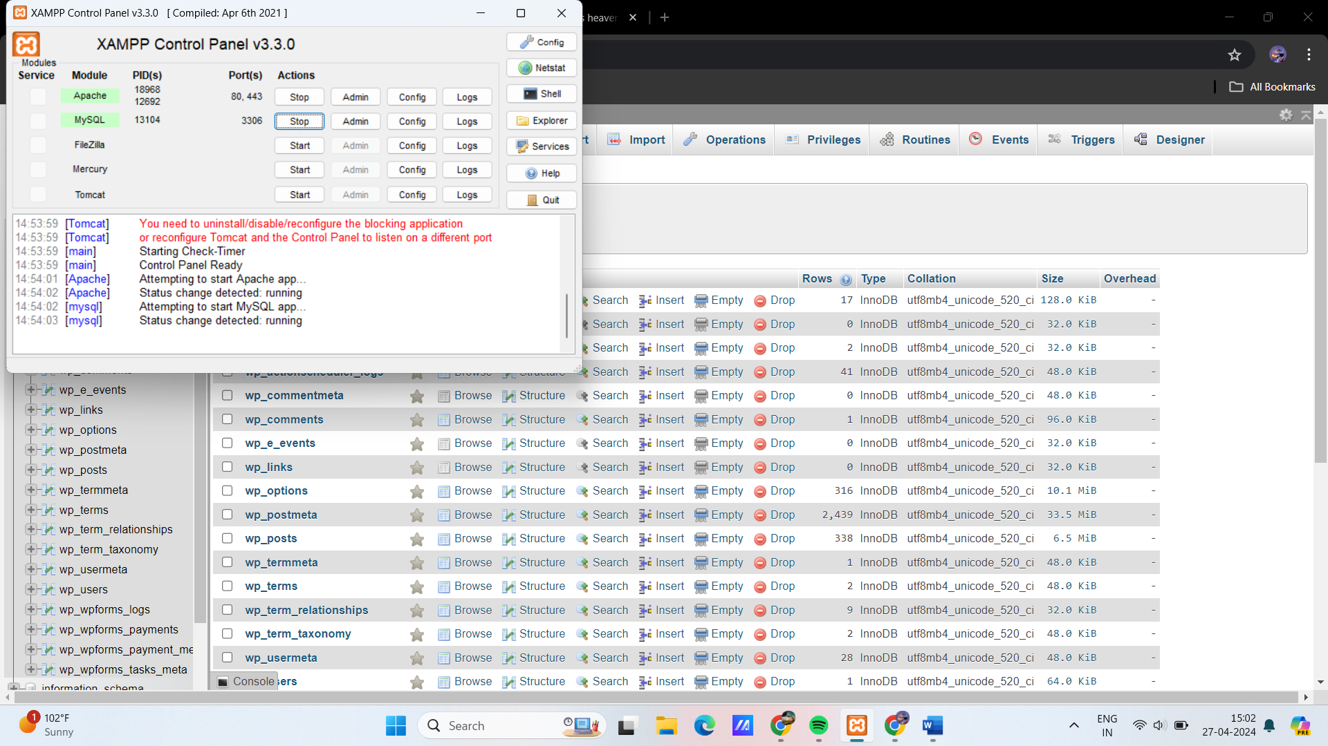

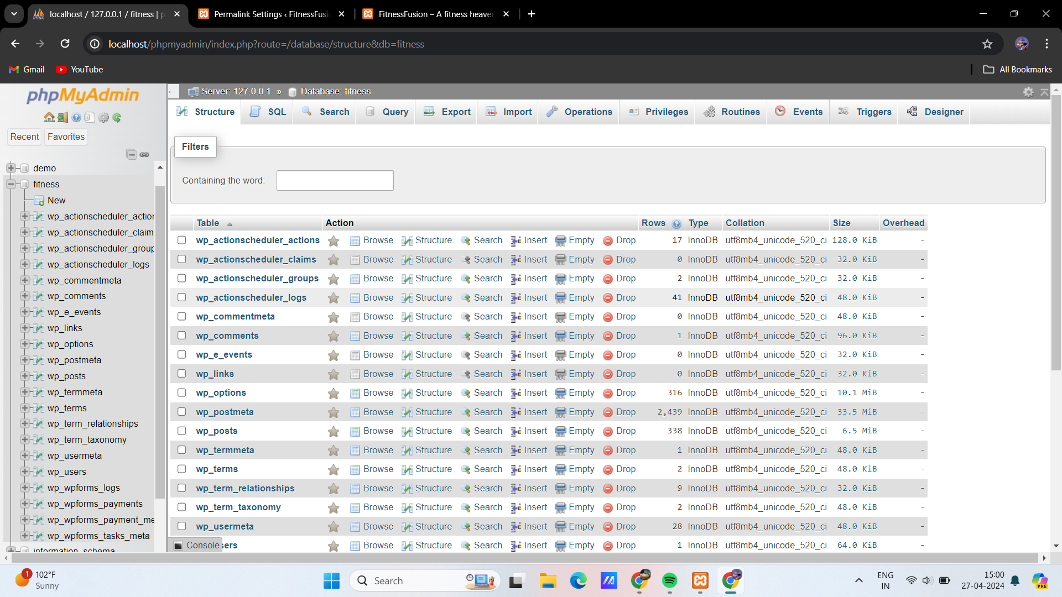

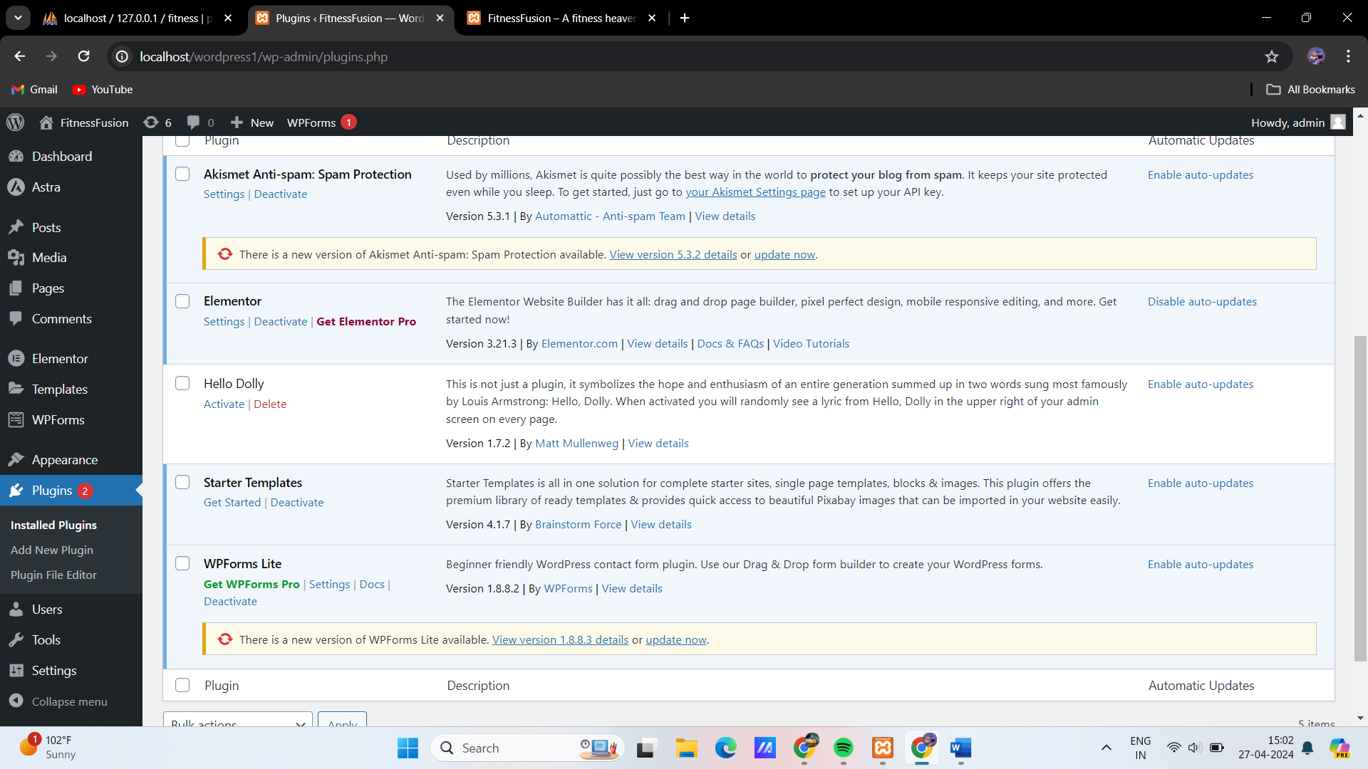

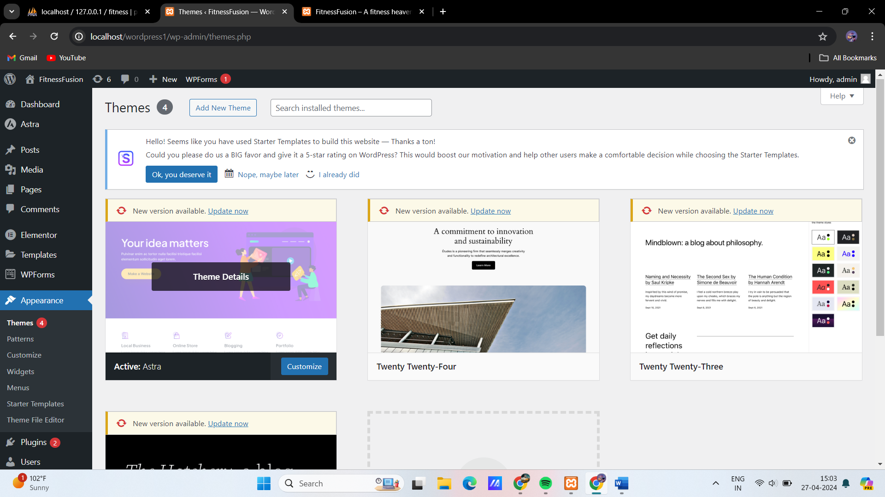

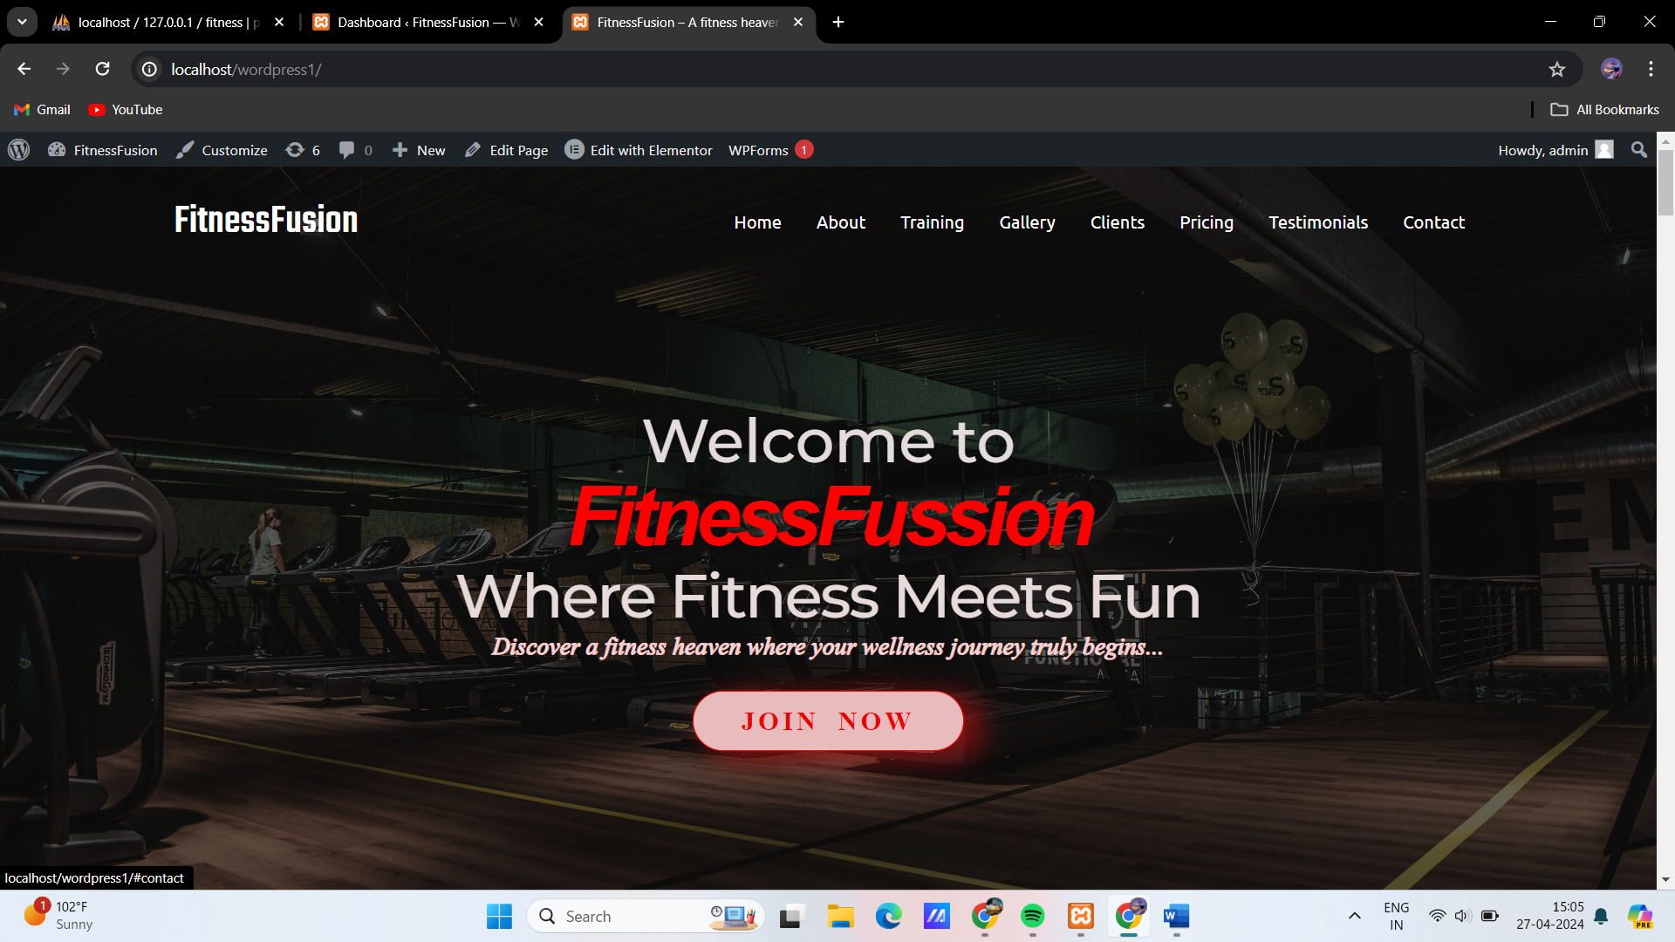

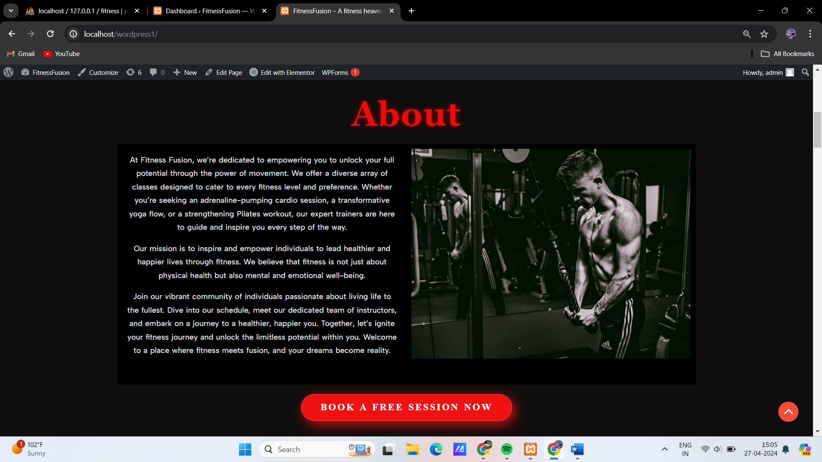

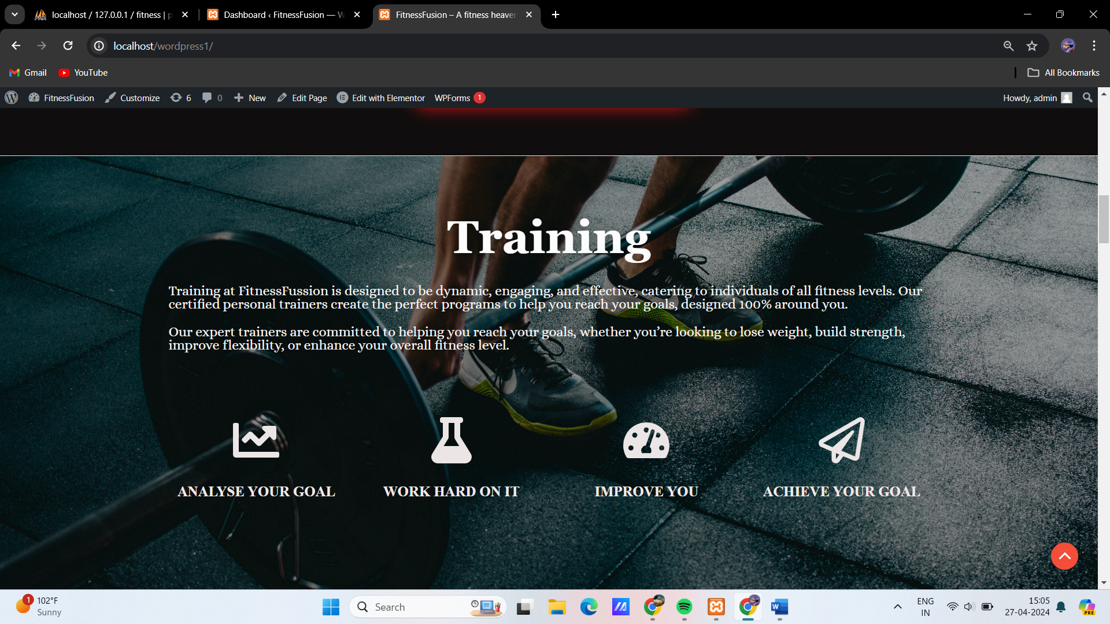

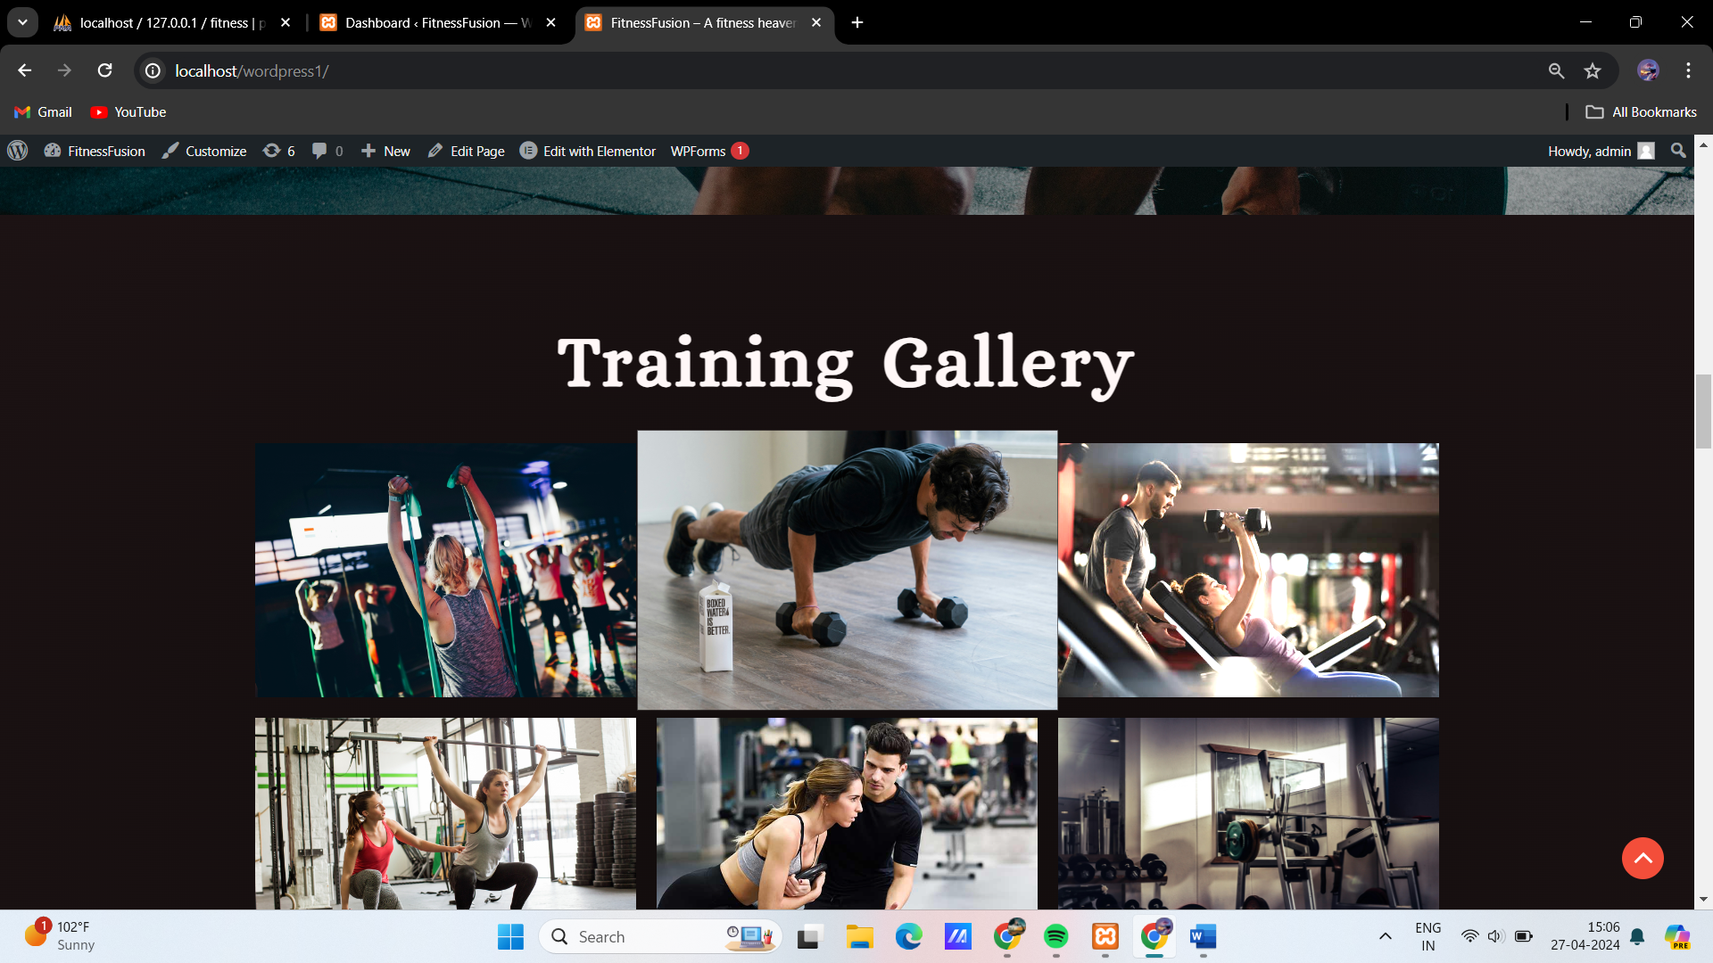

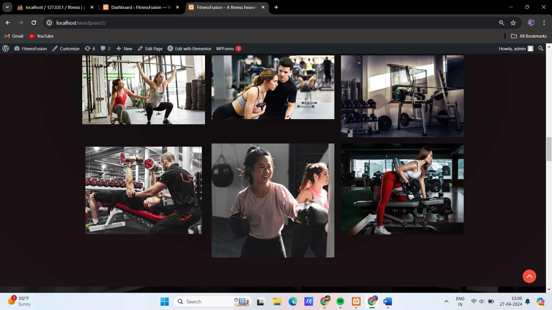

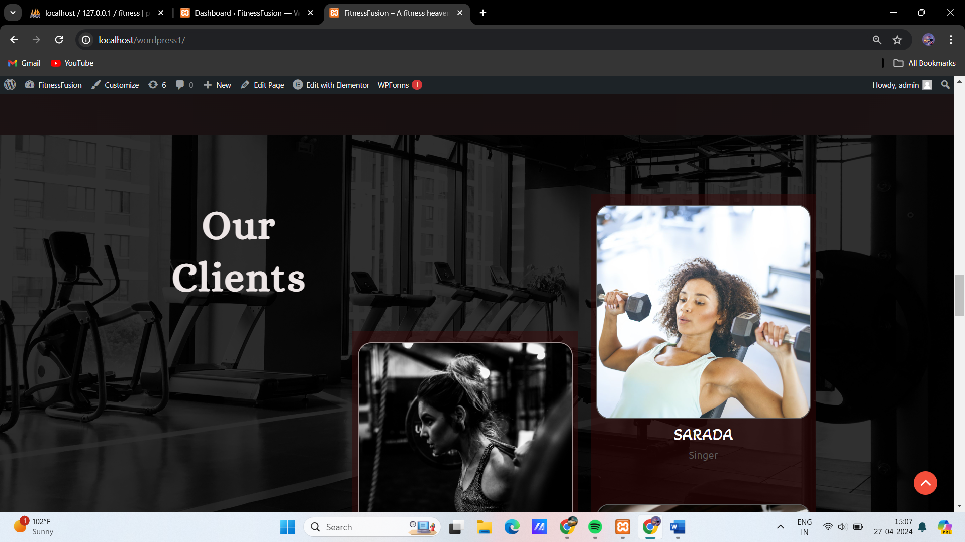

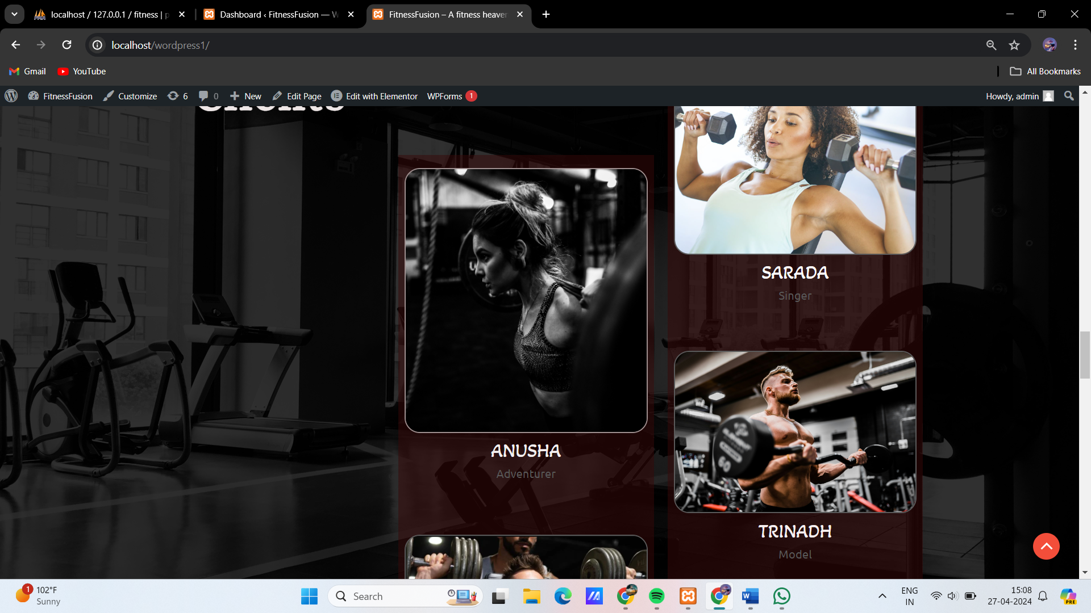

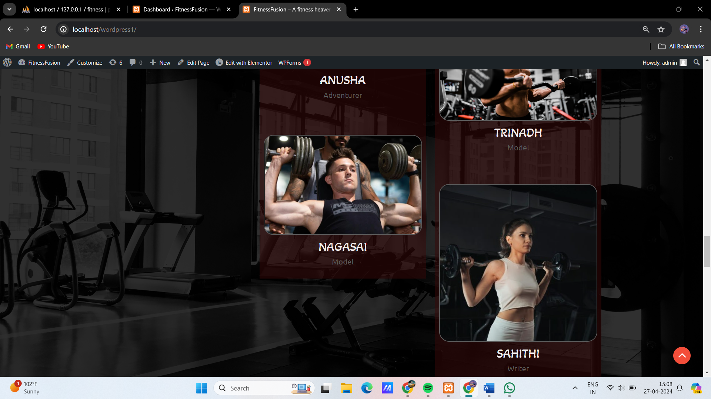

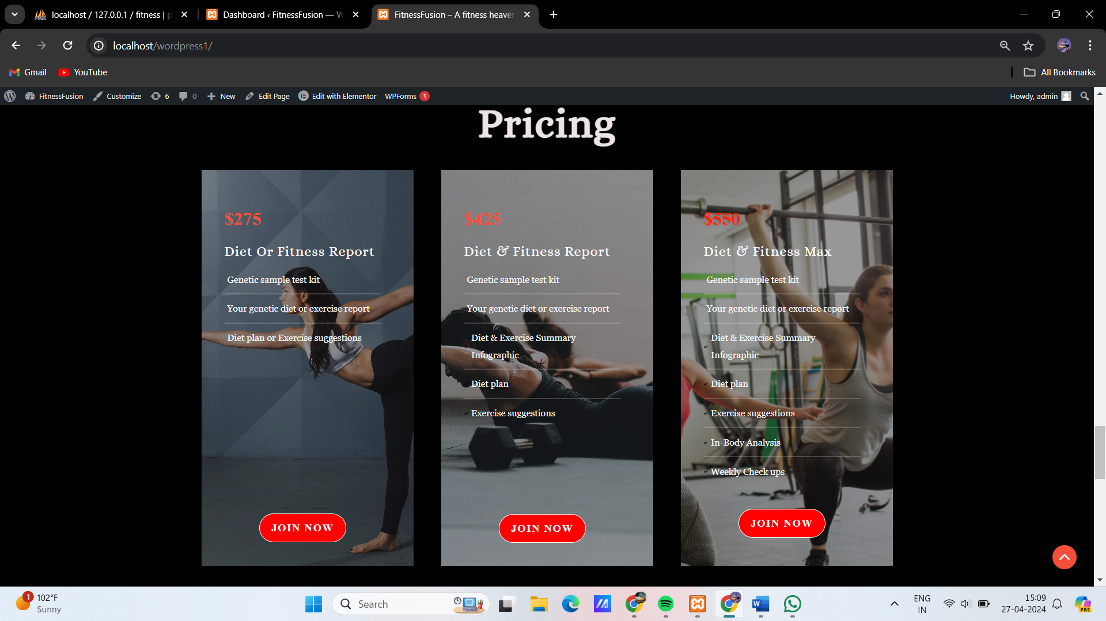

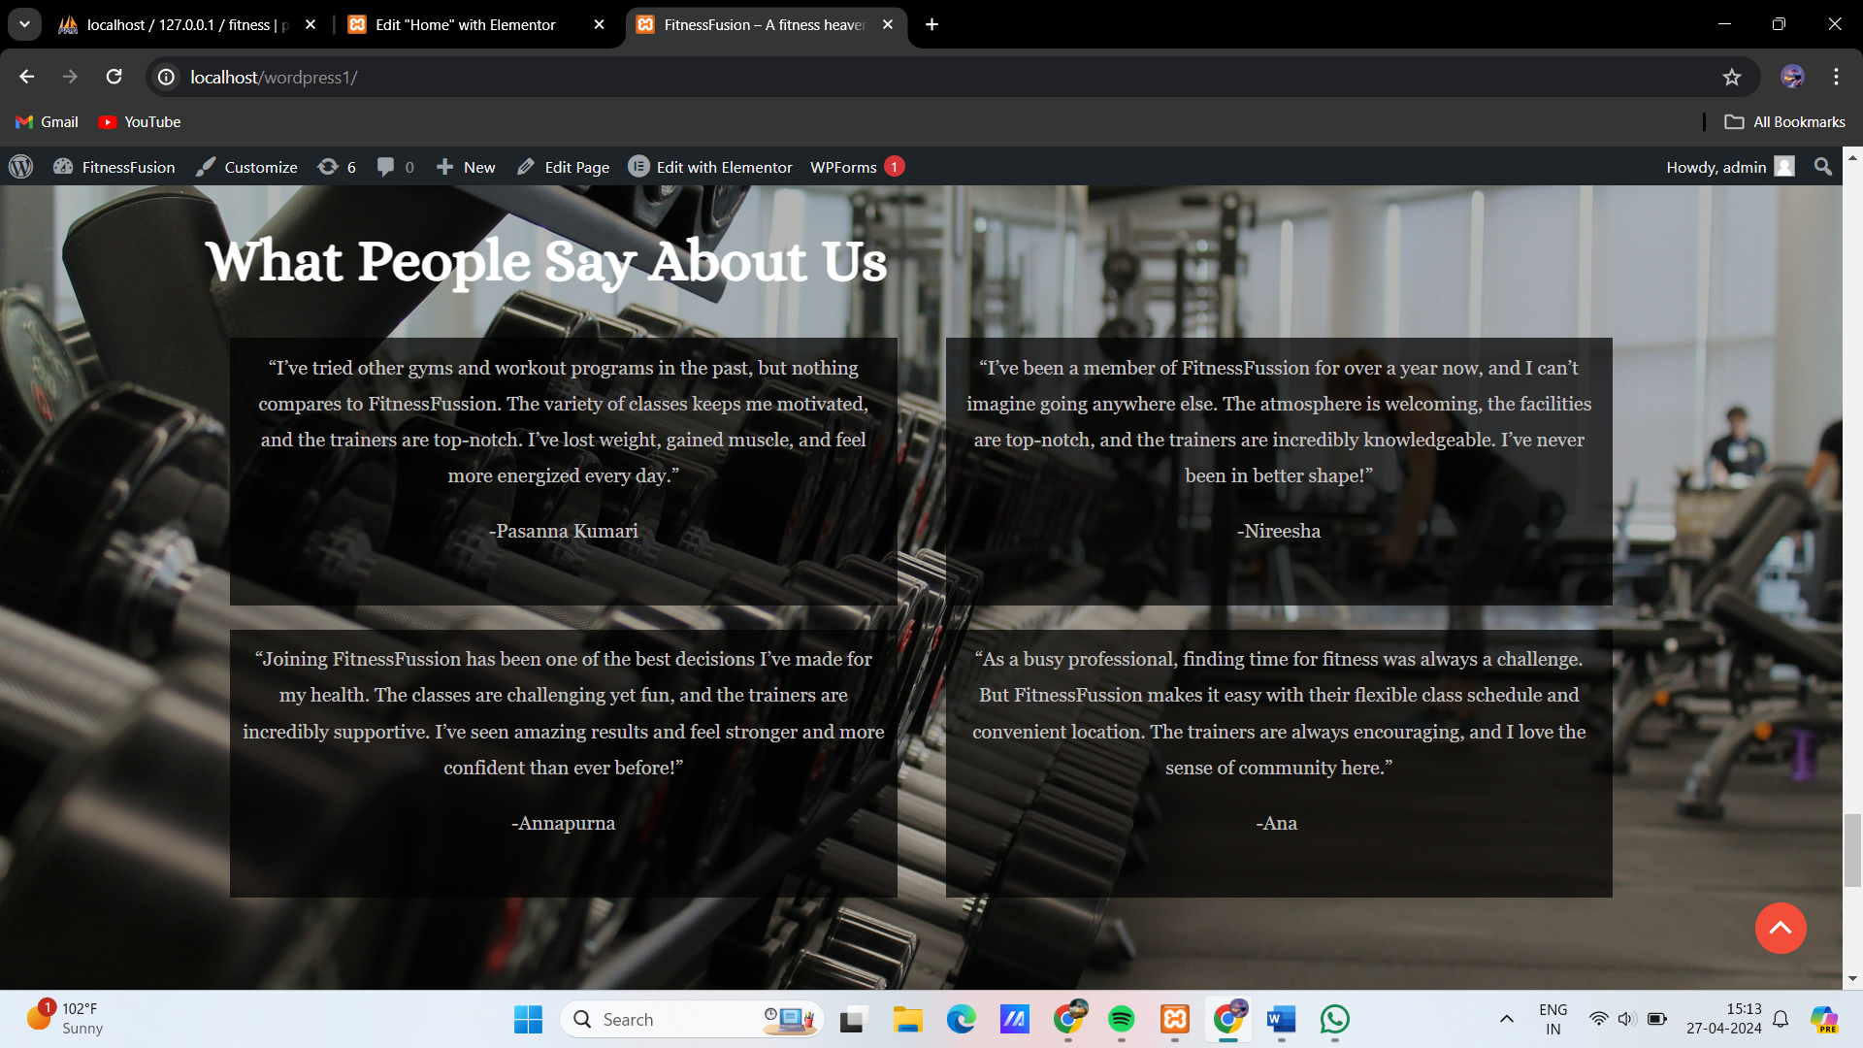

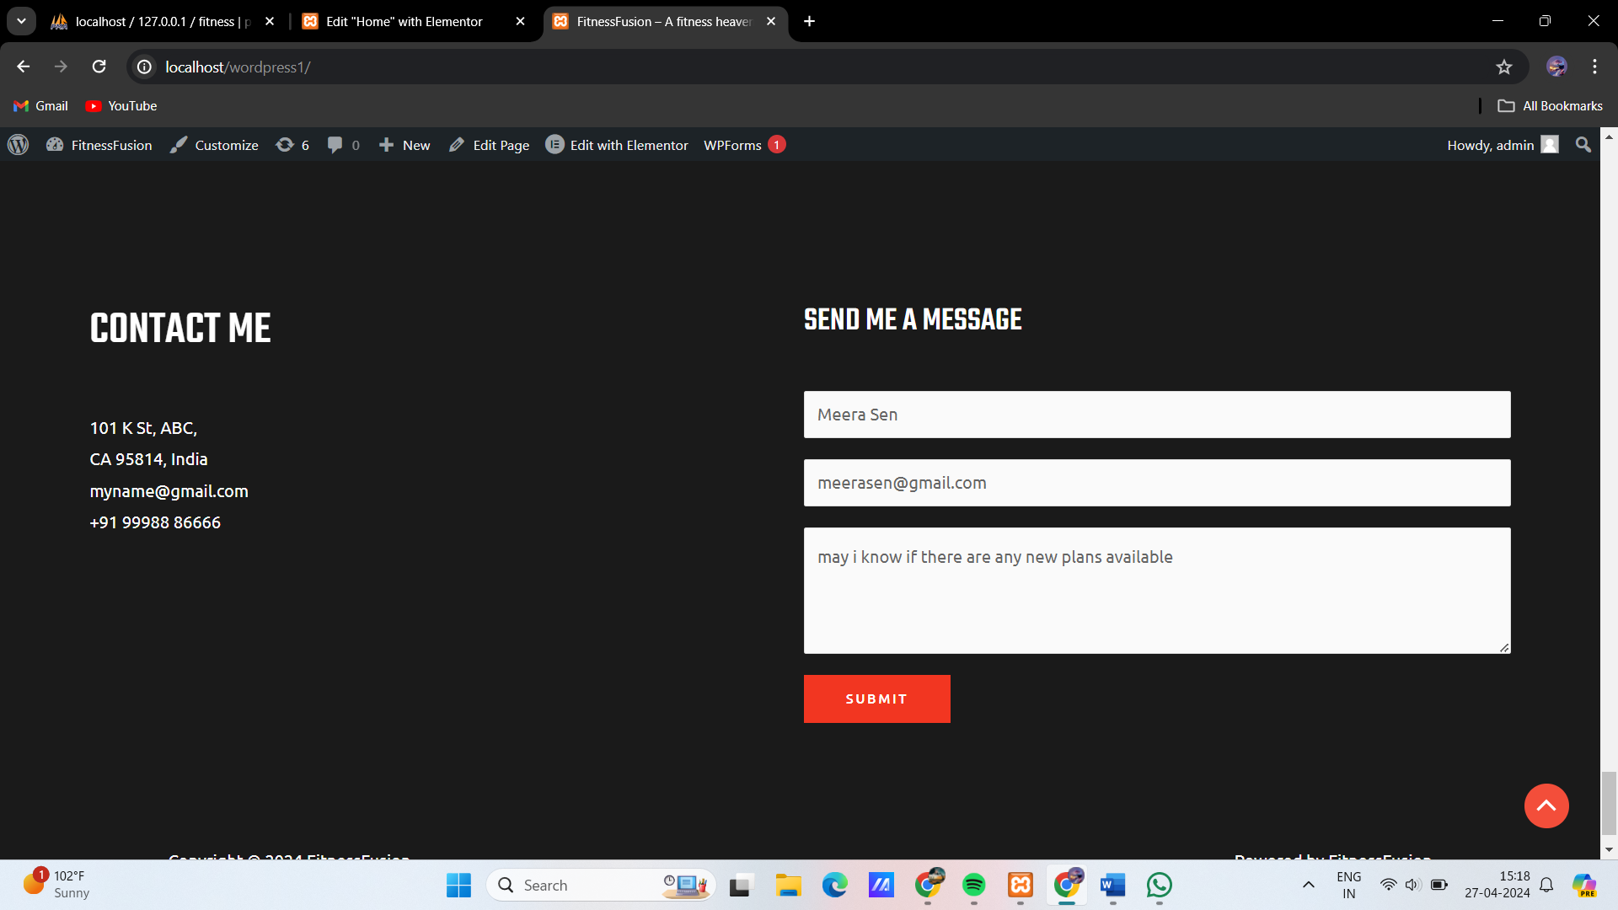

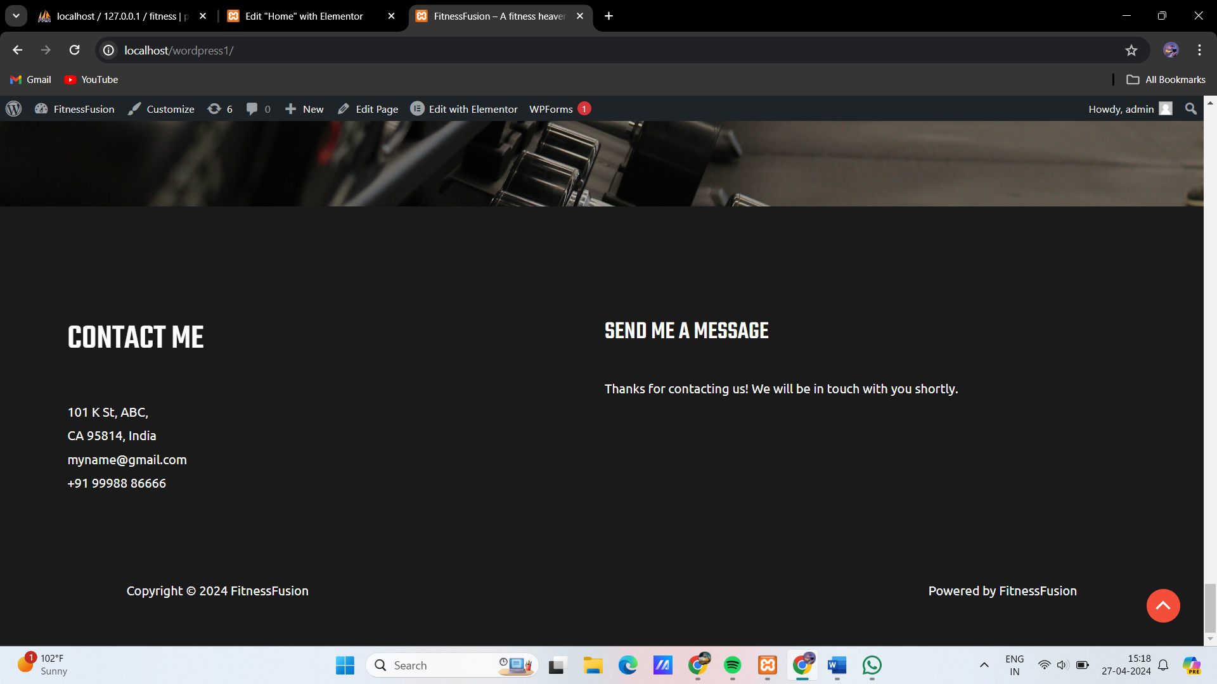

**Report**  
The Fitness Fusion website project was undertaken to develop a one-page WordPress site that would serve as a central hub for the studio's online presence. The primary objective of the project was to enhance the studio's visibility and attract new clients by providing a modern, user-friendly website. The scope of the project included requirements gathering, design, development, testing, and deployment.

The project followed a structured approach, starting with requirements gathering to understand the client's needs and preferences. This phase involved discussions with the client to identify key features and functionality required for the website. Based on the requirements gathered, the design phase began, which included creating wireframes and mockups to visualize the website's layout and user interface.

The development phase involved customizing WordPress themes and plugins to meet the client's requirements. This included creating a responsive design that would work seamlessly across different devices and screen sizes. The website was also optimized for performance to ensure fast loading times and a smooth user experience.

Testing was a crucial part of the project to ensure that the website functioned correctly and provided a positive user experience. This involved testing the website for functionality, compatibility, and performance. Compatibility testing was particularly important to ensure that the website worked across different browsers and devices.

Once the website was developed and tested, it was deployed to a live server. This involved transferring the website files to the server and configuring the domain name and hosting settings. Training was provided to the client on how to maintain the website, including updating content and managing bookings.

The outcome of the project was a successful launch of the Fitness Fusion website. The website features a modern, responsive design with sections for Home, About, Training, Training Gallery, Clients, Pricing, Testimonials, and Contact. The website has helped to enhance the studio's online presence and has attracted new clients.

In conclusion, the Fitness Fusion website project was a success, meeting the client's objectives of enhancing their online presence and attracting new clients. The website provides a modern, user-friendly platform for the studio to showcase their services and engage with clients. Ongoing maintenance and updates will be required to ensure the website continues to meet the studio's needs and remains a valuable asset for the business.

**APPENDIX B: User Manual**

**Fitness Fusion Website User Manual**

**Welcome to the Fitness Fusion Website!**

Thank you for visiting the Fitness Fusion website. Our website is designed to provide you with information about our fitness studio, including our services, trainers, and facilities. This user manual will guide you through the various sections of our website and help you make the most of your experience.

**1. Home Page:**

* The home page is the first page you will see when you visit our website. Here, you will find a welcoming message, featured classes or promotions, and call-to-action buttons for signing up or booking a class.

**2. About Us:**

* The About Us section provides information about our studio's history, mission, and values. You can also learn about our studio.

**3. Training:**

* The Training section details how our trainers design the train plan based on your profile.

**4. Training Gallery:**

* The Training Gallery showcases photos of our studio's facilities and classes. You can explore our training environment and get a feel for what it's like to train at Fitness Fusion.

**5. Clients:**

* The Clients section features our clients. You can read about their experiences and see how Fitness Fusion has helped them achieve their fitness goals.

**6. Pricing:**

* The Pricing section outlines our membership options and pricing plans. You can choose a membership package that suits your needs and budget.

**7. Testimonials:**

* The Testimonials section features feedback from our clients. You can read about their experiences and see how Fitness Fusion has helped them on their fitness journey.

**8. Contact:**

* The Contact section provides our contact information and a contact form for inquiries. You can reach out to us with any questions or feedback you may have.

**Additional Features:**

* Our website is designed to be user-friendly and easy to navigate. You can easily find the information you need and book classes or contact us with just a few clicks.

**Conclusion:**

* We hope this user manual has helped you navigate the Fitness Fusion website. If you have any questions or need further assistance, please don't hesitate to contact us. Thank you for choosing Fitness Fusion, and we look forward to helping you achieve your fitness goals!